SIMATS ENGINEERING
ASSESSMENT TOOL 1: Analytical Problem Solving

COURSE NAME: | Cloud Computing and Big Data Analytics | COURSE CODE: | CSA1506

COURSE OUTCOME COVERED
CO2: Analyze virtualization architectures to identify performance and security issues in cloud computing environments. (BL3)
Assessment Tool Weightage: 40%

Dave's Taxonomy: Manipulation (Level 2)  Question Count: 5 | Total Marks: 50

Code of Conduct
I Logeshwaran R- 192511175 (Name / Reg No) certify that this submission is my original work and that I have adhered to the guidelines specified for this assessment.
I understand that any violation of academic integrity rules will result in disciplinary action.
Signature of the student: 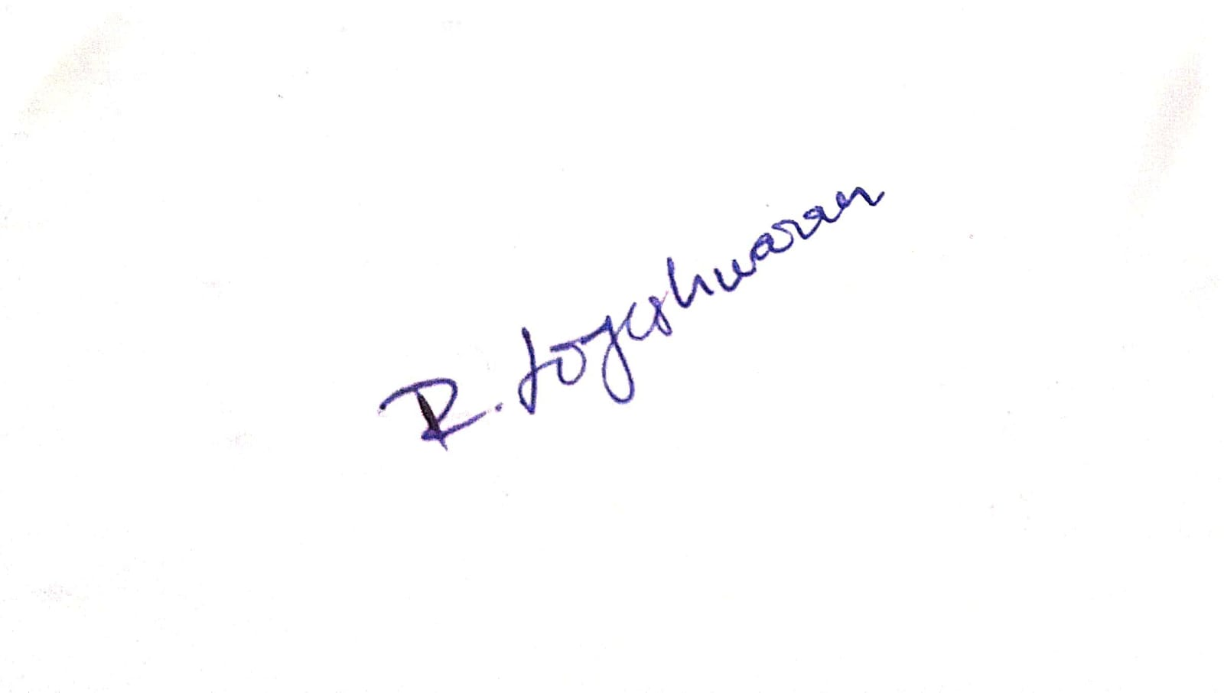

Assessment Tasks
Analytical Problem Solving
- Compare Type-1 and Type-2 hypervisors for a cloud datacenter hosting mission-critical applications. Analyze performance, security, and manageability, then justify the better choice.
Answers:
A cloud datacenter hosting mission-critical applications must choose between a Type-1 (bare-metal) hypervisor and a Type-2 (hosted) hypervisor. The choice is analyzed across performance, security, and manageability.
1. Architectural Difference
- Type-1 hypervisor: installs directly on the physical server and interacts with hardware natively; the host machine has no general-purpose operating system underneath it.
- Type-2 hypervisor: installs as an application on top of a conventional host operating system, so every hardware call passes through an extra software layer.
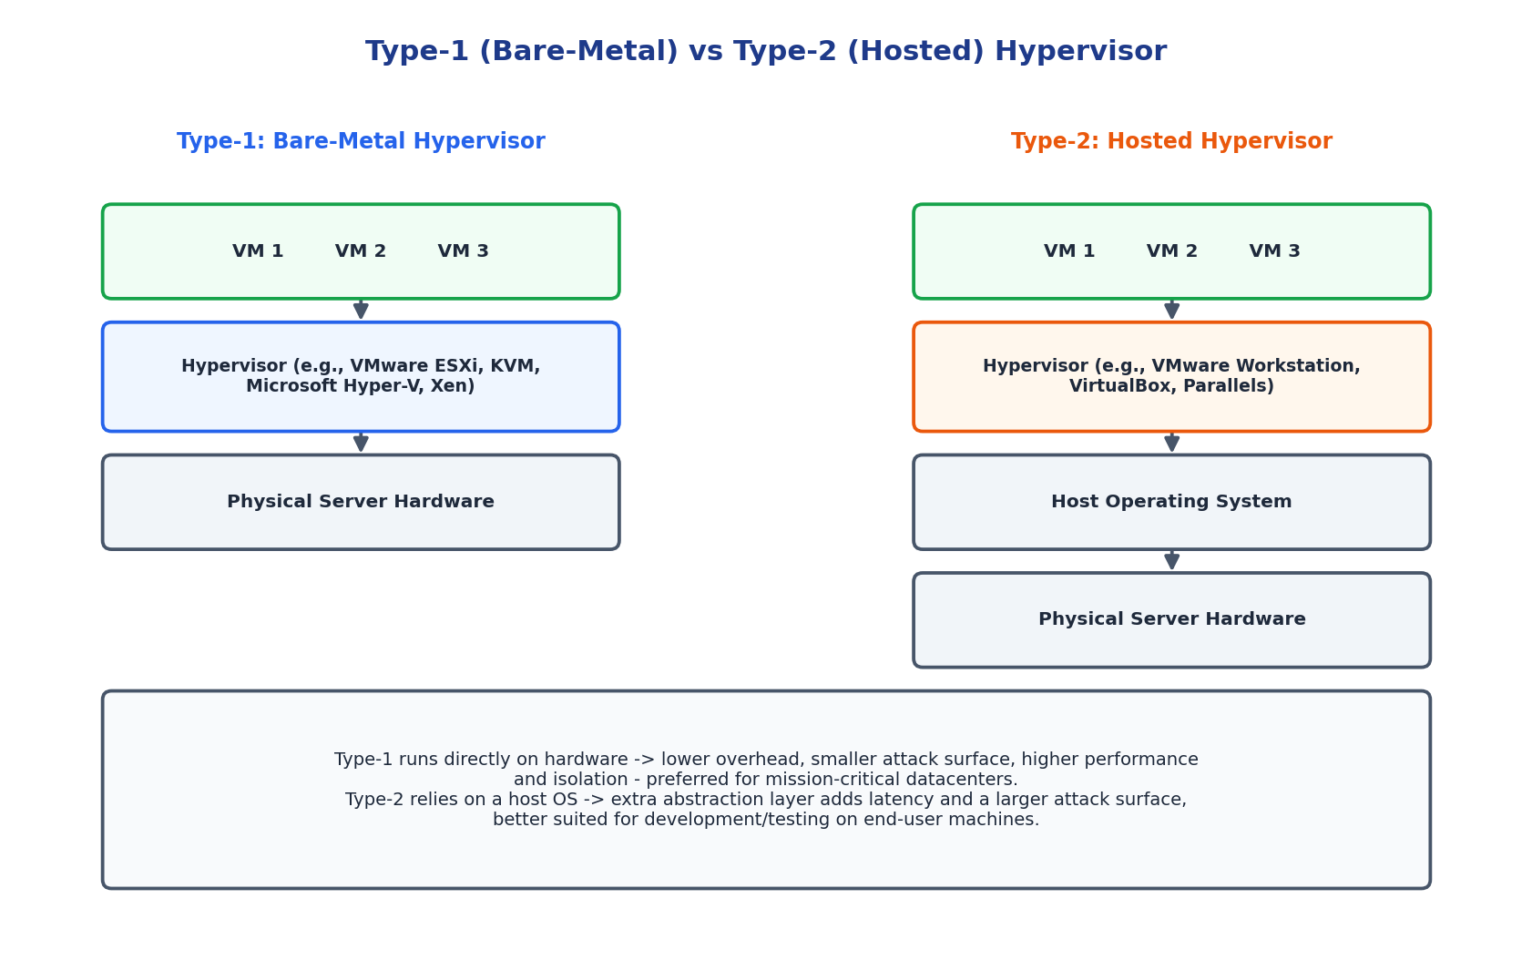
Figure 1.1: Architectural stack comparison of Type-1 and Type-2 hypervisors.
2. Comparison Table
Aspect | Type-1 Hypervisor (Bare-Metal) | Type-2 Hypervisor (Hosted)
Deployment | Runs directly on physical hardware; no host OS in between | Runs as an application on top of a host operating system
Performance | Near-native performance; minimal virtualization overhead | Lower performance due to extra OS abstraction layer
Security | Smaller attack surface; hypervisor has direct hardware control | Larger attack surface - vulnerable to host OS exploits too
Manageability | Requires specialized skills; centralized enterprise tooling (vCenter, SCVMM) | Easy to install/manage on a normal desktop OS
Typical Use Case | Production datacenters, mission-critical enterprise workloads | Developer sandboxes, testing, personal/desktop virtualization
Examples | VMware ESXi, Microsoft Hyper-V, KVM, Citrix Xen | VMware Workstation, Oracle VirtualBox, Parallels Desktop

3. Analysis
- Performance: Type-1 hypervisors talk to hardware directly, giving near-native CPU, memory, and I/O performance essential for latency-sensitive, mission-critical workloads. Type-2 hypervisors compete with the host OS for resources, adding scheduling overhead and unpredictable latency.
- Security: Type-1's minimal, purpose-built hypervisor kernel presents a much smaller attack surface, and a compromise of the host OS (a risk unique to Type-2) is not a threat vector. Type-2 inherits every vulnerability of its host OS in addition to the hypervisor's own, effectively doubling the exposed surface.
- Manageability: Type-1 platforms come with enterprise-grade centralized management (vCenter, System Center) supporting live migration, clustering, and automated failover - critical for uptime guarantees. Type-2 platforms are simpler to install but lack this operational tooling, since they are designed for individual desktops rather than fleets of servers.
4. Justification - Recommended Choice
For a datacenter hosting mission-critical applications, a Type-1 (bare-metal) hypervisor is the better choice. It delivers the performance headroom mission-critical workloads need, minimizes the attack surface that regulators and auditors scrutinize, and integrates with enterprise management/orchestration tooling required for high availability at datacenter scale. Type-2 hypervisors remain appropriate only for development, testing, or isolated desktop use cases where convenience matters more than production-grade performance and security.

- A cloud provider must isolate workloads belonging to finance, healthcare, and student portals on the same hardware. Analyze how virtualization architecture supports isolation and identify two major attack surfaces.
Answers:
A cloud provider must run finance, healthcare, and student-portal workloads on the same physical hardware while keeping each tenant fully isolated from the others.
1. How Virtualization Architecture Supports Isolation
- Hardware-level partitioning: The hypervisor uses CPU virtualization extensions (Intel VT-x/AMD-V) to allocate dedicated virtual CPU time slices and enforce memory address-space separation, so one VM cannot directly read or write another VM's memory.
- Virtual network segmentation: Each tenant's VM is placed on an isolated virtual switch/VLAN or VXLAN overlay, with firewall and security-group rules preventing east-west traffic between tenants unless explicitly permitted.
- Storage isolation: Virtual disks are logically separated per VM, often with per-tenant encryption keys, so storage-layer access does not cross tenant boundaries even on shared physical disks.
- Policy-based resource control: Resource pools/quotas (CPU shares, memory limits, I/O throttling) prevent one tenant (e.g., a traffic spike on the student portal) from starving another tenant's (e.g., finance) resources - a form of isolation for availability, not just confidentiality.
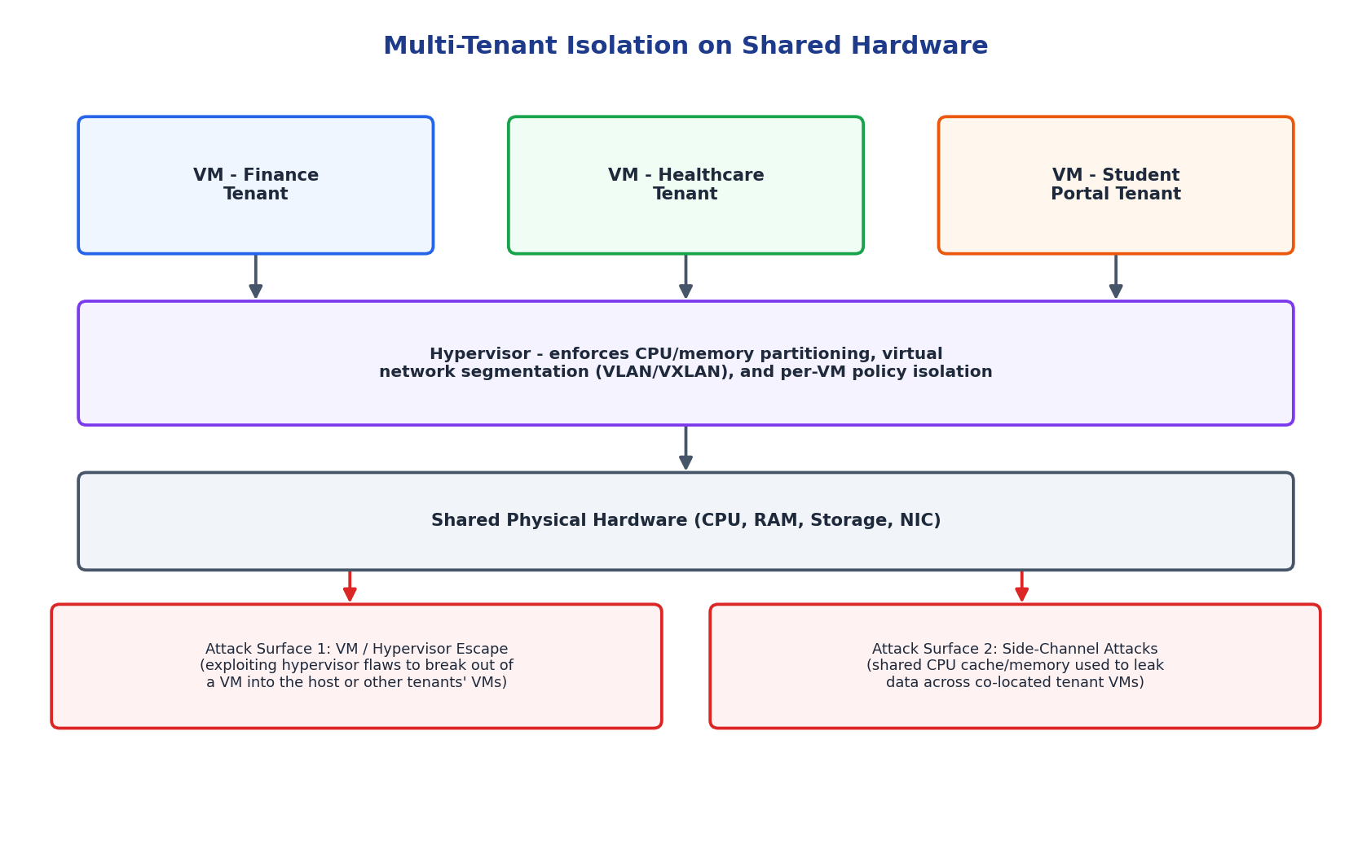
Figure 2.1: Multi-tenant isolation architecture with two major attack surfaces highlighted.
2. Two Major Attack Surfaces
- VM / hypervisor escape: A flaw in the hypervisor's device-emulation or memory-management code could let an attacker inside one VM break out and gain control of the hypervisor itself, or pivot directly into a co-located tenant's VM. Given that healthcare and finance data are highly regulated, this is the single most critical risk to mitigate through timely hypervisor patching and hardened configurations.
- Side-channel attacks: Because tenants share physical CPU caches, memory buses, and sometimes storage media, an attacker can use timing or cache-based side-channel techniques (e.g., Spectre/Meltdown-class attacks) to infer data from a neighboring tenant's VM without ever breaching the hypervisor boundary directly.
Mitigations include keeping hypervisors patched against known escape CVEs, enabling tenant-aware CPU scheduling/cache-partitioning features, considering dedicated (non-shared) hosts for the most sensitive tenant (e.g., healthcare data under HIPAA-type regulation), and continuous security monitoring for anomalous cross-tenant behavior.

- Study the following VM host utilization snapshot and recommend corrective actions: CPU 92%, memory 88%, storage I/O latency 35 ms, average VM boot time 170 s. Explain the likely bottlenecks.
Answer:
Observed metrics: CPU 92%, memory 88%, storage I/O latency 35 ms, average VM boot time 170 seconds. These figures are analyzed against typical safe operating thresholds to identify the underlying bottlenecks.
1. Identifying the Bottlenecks
- CPU at 92% (threshold ~80%): The host is CPU over-committed - too many vCPUs are contending for too few physical cores, causing CPU ready/wait time for every VM and directly slowing all workloads, including the boot process.
- Memory at 88% (threshold ~80%): The host is close to physical memory exhaustion. This forces the hypervisor into memory-reclamation techniques such as ballooning or swapping to disk, which is far slower than RAM and compounds the I/O problem below.
- Storage I/O latency at 35 ms (threshold ~20 ms): This is well above the ~10-20 ms range expected of healthy shared storage, indicating either a disk/array approaching saturation or hypervisor-level memory swapping spilling onto disk (consistent with the memory pressure above).
- VM boot time at 170 s (threshold ~60 s): This is the visible symptom, not a separate root cause - boot involves heavy simultaneous CPU, memory, and disk I/O, so it is the metric most affected when all three underlying resources are constrained at once.
2. Likely Root Cause
The pattern points to VM sprawl / over-provisioning on this host: too many VMs (or over-sized VMs) have been packed onto hardware whose CPU and memory capacity was already close to its limit, and the resulting memory pressure is spilling over into storage I/O contention. The elevated boot time is a downstream effect of all three resources being saturated simultaneously, not an independent fault.
3. Corrective Actions
- Right-size VMs: audit vCPU/vRAM allocations against actual guest utilization and reclaim over-allocated resources.
- Rebalance load: use vMotion/live migration (DRS-style automation) to move some VMs to less-loaded hosts in the cluster.
- Add capacity: if the cluster overall is undersized, scale out with additional hosts or upgrade CPU/RAM on this host.
- Tune storage: move latency-sensitive VMs to faster storage tiers (SSD/NVMe) or add IOPS capacity; check for a failing/degraded disk in the array.
- Set resource limits and reservations per VM to prevent any single workload from starving others, and configure proactive alerting before thresholds are breached again.

- Analyze how Software Defined Datacenter architecture improves agility compared with a traditional datacenter. Support your answer with compute, storage, and network virtualization considerations.
Answer:
A Software-Defined Datacenter abstracts compute, storage, and networking into software-controlled pools, in contrast to a traditional datacenter built on fixed, manually configured hardware.
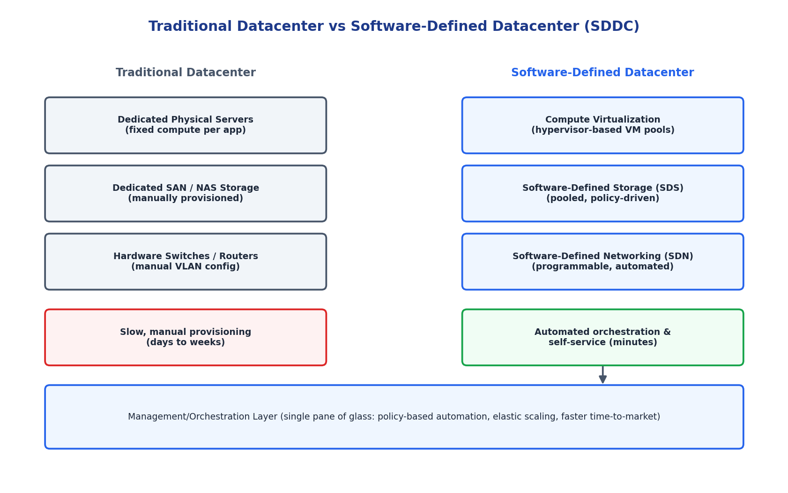
Figure 4.1: Traditional siloed infrastructure versus a virtualized, software-defined datacenter.
1. Compute Virtualization
In a traditional datacenter, applications are typically bound to dedicated physical servers, so adding capacity means procuring and racking new hardware - a process that takes weeks. In an SDDC, a hypervisor layer pools compute across all physical hosts; new virtual machines or containers can be provisioned from that shared pool in minutes, and workloads can be live-migrated between hosts for load balancing or maintenance with zero downtime.
2. Storage Virtualization
Traditional storage (SAN/NAS) is manually carved into LUNs and assigned to specific applications, requiring a storage administrator for every change. Software-Defined Storage (SDS) pools all available disks across the cluster and exposes them through policy-based provisioning (e.g., 'this application needs SSD-tier, 3-way replicated storage'), letting the system automatically place and protect data without manual LUN management.
3. Network Virtualization
Traditional networking relies on physically configuring VLANs and firewall rules on individual switches - slow and error-prone at scale. Software-Defined Networking (SDN) decouples the network control plane from physical switches, so network segments, firewall policies, and load balancers can be created, changed, and torn down entirely in software, directly tied to application lifecycle (e.g., an isolated network segment is spun up automatically whenever a new application is deployed).
4. Overall Agility Improvement
- Provisioning time drops from days/weeks (manual hardware and network changes) to minutes (self-service, API-driven automation).
- A single orchestration/management layer gives unified visibility and policy control across compute, storage, and network, instead of three separate manual silos.
- Elastic scaling becomes possible: resource pools grow or shrink automatically with demand, unlike fixed-capacity physical hardware.
- Infrastructure-as-code practices become viable, enabling repeatable, auditable, and faster deployments that directly support DevOps/CI-CD workflows.

- A multi-cloud federation project fails due to identity mismatches between providers. Analyze the issue and propose a secure identity and privacy design using federation concepts.
Answer:
A multi-cloud federation project has failed because identity information does not match consistently between the different cloud providers involved.
1. Analysis of the Root Issue
- Each cloud provider maintains its own identity store (AWS IAM, Azure AD, GCP IAM) with different attribute names, role definitions, and token formats, so a user's identity does not translate cleanly from one provider to another.
- Without a common trust anchor, providers cannot verify who is authenticating on another provider's behalf, leading to failed logins, duplicated accounts, or - worse - overly permissive fallback access being granted.
- Inconsistent attribute/claim mapping (e.g., a 'department' claim meaning different things in each system) causes authorization decisions to be wrong even when authentication itself succeeds.
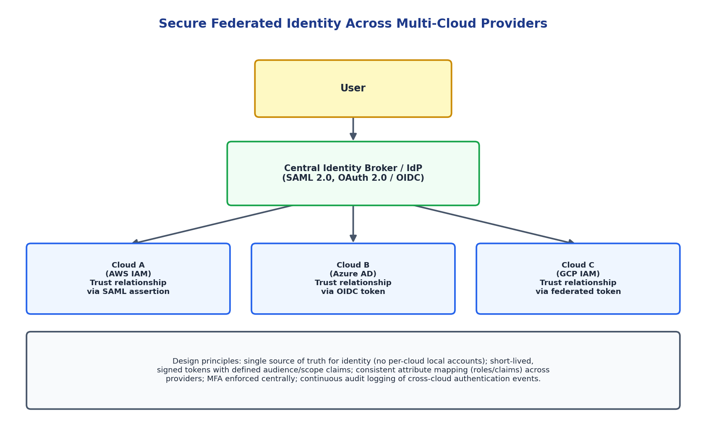
Figure 5.1: Federated identity design using a central identity broker trusted by every cloud provider.
2. Proposed Secure Identity and Privacy Design
- Central Identity Broker / Identity Provider (IdP): Introduce one authoritative IdP that all clouds trust, using open federation standards - SAML 2.0 for enterprise SSO or OAuth 2.0/OpenID Connect for token-based access - so users authenticate once centrally rather than maintaining separate credentials per cloud.
- Standardized claims/attribute mapping: Define a common schema for identity attributes (role, department, tenant) and map each cloud provider's native identity format to this schema at the broker, eliminating mismatches.
- Short-lived, scoped tokens: Issue signed tokens with a defined audience (which cloud it is valid for), narrow scope (least privilege), and short expiry, reducing the blast radius if a token is intercepted.
- Consistent MFA and conditional access: Enforce multi-factor authentication and risk-based access policies centrally at the broker so security posture is uniform across all three clouds instead of varying per provider.
- Privacy protection: Share only the minimum identity attributes each cloud provider needs (data minimization), encrypt identity tokens/assertions in transit, and maintain a central, tamper-evident audit log of all cross-cloud authentication events for compliance and incident investigation.
3. Outcome
With a single federated identity broker as the trust anchor, every cloud provider verifies users against the same source of truth, attribute mismatches are resolved through standardized mapping, and access remains auditable and least-privilege - resolving the federation failure while improving overall security posture.

Analytical Problem Solving Rubric

Criteria | Weightage | Level 4 - Exemplary | Level 3 – Proficient | Level 2 - Developing | Level 1 - Beginning
Problem Interpretation | 20% | Interprets all technical requirements accurately | Interprets most requirements correctly | Partial interpretation | Misinterprets the problem
Analytical Reasoning | 25% | Strong reasoning with clear cause-effect analysis | Good reasoning with minor gaps | Basic analysis only | Weak or no analysis
Method Selection | 20% | Chooses highly appropriate virtualization and security concepts | Chooses mostly suitable concepts | Partially suitable concepts | Inappropriate approach
Solution Quality | 20% | Provides feasible and technically sound solution | Reasonable solution with minor issues | Basic solution with limitations | Unclear or invalid solution
Presentation of Analysis | 15% | Well-structured and technically precise | Generally clear | Somewhat unclear | Difficult to follow

Total Marks Awarded:

